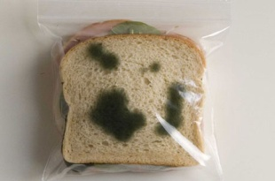
Name:
Mr Schulz has a problem and needs your help.
His bread keeps getting mouldy, gross! He can’t eat it because it will make him sick. The question for you is how can he best store it his bread…? Keep an eye on the bread over the next week and record your results.

 | Monday | Tuesday | Wednesday | Thursday | Friday
Kept in the sunlight
Kept in the dark
Kept in the fridge
Aim: What is your experiment?

Hypothesis: What do you think will happen?

Materials: What is needed to do the experiment?

Method: How do you do the experiment? (Dot points)

Results: At the end of the week

Diagram: Draw 3 diagrams at the end of the week (one of each type of bread stored)

Conclusion: Where should Mr Schulz keep his bread?

Due Friday 23rd May Week 4

